Abdul Moiz Mansab

Muhammad Aqeel

Software Development and Construction

Projects Artifacts

**Stakeholders:**

**Admin:**

**1. Manage Staff Accounts**

1. Add new staff
2. Update staff details
3. Remove staff accounts
4. Monitor book issues/returns
5. Track overdue and fines
6. Oversee user activity
7. Generate usage reports (books borrowed, categories)
8. Generate fine reports
9. Generate user activity reports

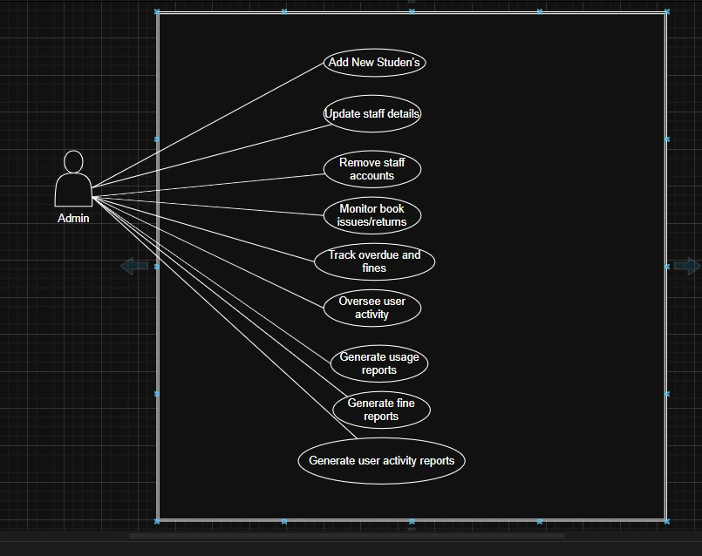

**Library Staff**

Issue Books

* Check book availability
* Assign due date to the user
* Record the transaction in the system

Return Books

* Receive returned books from students
* Update the system to mark book as available again ● Calculate fines (if overdue)

Maintain Records

* Keep book inventory updated (add/update/remove books)
* Track issued and returned books
* Maintain fine/overdue history

Manage Student Accounts

* Create new student accounts (with unique IDs)
* Update student information (class, name, etc.)
* Deactivate accounts for graduated/inactive students

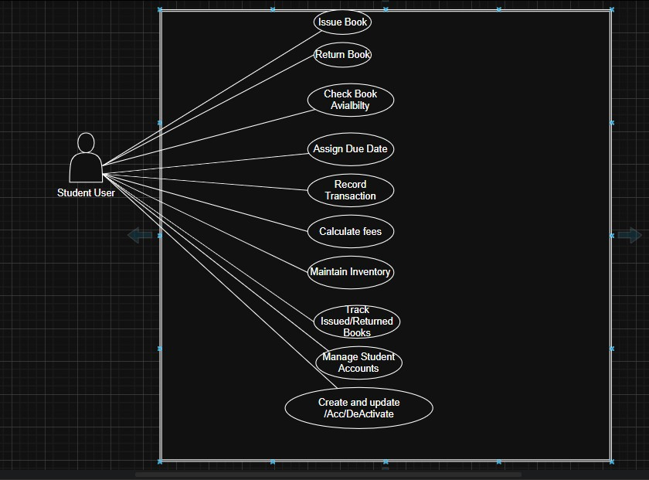

Lib

rary Sta

ff

# Students/Users — Use Cases to Add in UML Diagram

1. Search Catalog (by title, author, category)
2. Borrow Books
3. Return Books
4. View Issued Books
5. Check Due Dates
6. View Fine Details (optional if fines are visible to students)
7. Receive Notifications (due/overdue reminders)

